
AvSport of Lock Haven
353 Proctor Street
Lock Haven PA 17745

Gateway to the Sky ^{tm}
Gift Certificate

A Gift to: From:

This signed certificate is good for one Introductory Flight Lesson with Prof. H. Paul Shuch, AvSport’s Chief Flight Instructor, in our quality Light Sport Aircraft trainer. The bearer of this certificate will get to fly the plane at the Piper Memorial Airport, Lock Haven PA, and will receive a complementary photograph and logbook (with the first lesson entered and signed). This certificate is valid for one year from the issue date below. Call to schedule your no-obligation lesson.

Signed: Date Issued:

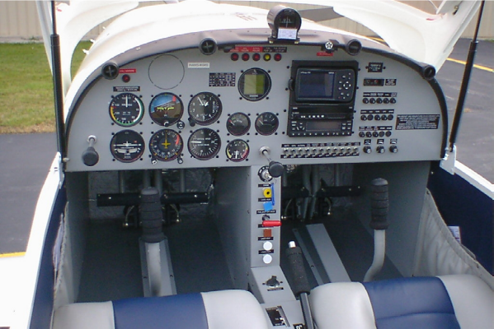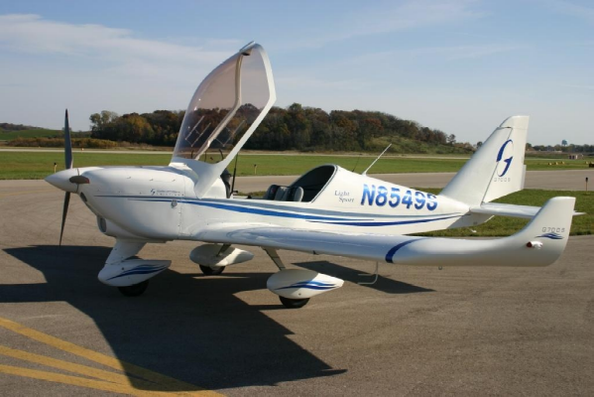

The Fine Print: Certain weight, height, and health restrictions apply. Persons weighing more than 200 pounds can be accommodated only by prior arrangement. We regret that our aircraft cannot safely carry passengers weighing in excess of 250 pounds. Demo Flight recipients will be asked to sign our standard Liability Waiver form.

